Semester Project Report
“Data Encryption through STEGANOGRAPHY in Python”

Group Members:
1. USAMA NOOR | Swen231101006
2. Hamid Javed | Swen231101005
3. Husnain Ali | Swen231101010
4. Zahid Ali | Swen231101050

Course Name | Information Security
Department | Software Engineering
Instructor Name | Engr. Zahid Muneer
Date of Submission | 20-05-2025

“Stego by UHZH”
Make any data secure

“Data Encryption through Steganography in Python”
"Hide Secrets in Plain Sight – Secure, Encrypted, and Undetectable!"
The project "Stego by UHZH" addresses the need for secure and discreet communication by embedding encrypted messages within image files using steganography. It combines symmetric password-based encryption with a user-friendly GUI that supports drag-and-drop functionality, scrollable text, and optional password logging. The system ensures both data confidentiality and usability in a lightweight desktop application.

Problem Statement:
Develop a Python-based steganography application to securely encode and decode text messages within PNG images. The system should allow users to hide encrypted messages using password protection, extract hidden data with the correct password, and log encryption keys for audit purposes—all through an intuitive graphical user interface.

Key Features Included:
1. Encoding/Decoding (LSB steganography)
2. AES-256 Encryption (password-protected)
3. GUI (Tkinter with drag-and-drop support)
4. CSV Key Logging (timestamps, filenames)

Abstract:
This project presents a Python-based desktop application for hiding and retrieving secret messages within images using steganography and symmetric key encryption. Named “Stego by UHZH”, the tool leverages LSB (Least Significant Bit) techniques to embed encrypted data into images, allowing users to encode and decode messages securely with a password. The GUI is built with Tkinter and supports features like drag-and-drop, scrollable message boxes, password masking, and automatic logging of passwords in a local CSV file. The goal is to make digital data security more accessible and intuitive through a lightweight application.

Table of Contents
- Introduction
- Objectives
- Methodology
- Tools & Technologies
- System Design & Architecture
- Code Structure
- GUI Overview
- Functional Explanation
- Encryption Logic
- Steganography Logic
- Line-by-Line Code Explanation
- User Flow
- Test Cases & Validation
- Limitations & Challenges
- Security Considerations
- Results
- Future Enhancements
- Conclusion
- References

1. Introduction
In the age of digital communication, ensuring data privacy is critical. Steganography provides a powerful means to hide data within other files like audio, image and video files, making it nearly undetectable. This project uses Python to implement a desktop GUI application where users can hide (encode) and retrieve (decode) messages within image files only using a password. The system combines image processing and cryptography into a single user-friendly tool.

2. Objectives
- Embed and retrieve messages within image files.
- Hide text data within image pixels using LSB steganography.
- Extract hidden data while preserving original image quality.

- Secure messages using password-based symmetric encryption.
- Encrypt messages with AES-256 before embedding.
- Decrypt only with the correct password for security.

- Provide a GUI for ease of use.
- Build intuitive windows for encode/decode operations.
- Use Tkinter for cross-platform compatibility.

- Support drag-and-drop interaction for images.
- Allow image import via file drag-and-drop.
- Streamline user workflow for faster processing.

- Save passwords locally in CSV for learning/demo purposes.
- Store encrypted keys with timestamps for demo purposes.
- Exclude plaintext passwords for security compliance.

3. Methodology
- Convert messages into encrypted strings using a password.
- Convert text to ciphertext using Fernet (AES-256).
- Derive encryption keys from SHA-256 hashed passwords.

- Convert the encrypted message into binary.
- Transform encrypted data into 8-bit binary strings.
- Pad binary to ensure fixed-length pixel modifications.

- Modify image pixel LSBs to embed the binary data.
- Replace least significant bits of RGB pixels with binary data.
- Use 9th channel (3rd pixel's LSB) as termination marker.

- During decoding, extract the binary from image pixels.
- Scan pixel LSBs sequentially to reconstruct binary.
- Stop extraction when termination marker is detected.

- Decrypt it using the same password.
- Convert extracted binary to encrypted string.
- Decrypt only if password hash matches original key.

- Provide GUI interface for encoding/decoding workflows.
- Separate windows for encode/decode with input validation.
- Real-time feedback via popups and disabled states.

4. Tools & Technologies
Tool | Purpose
Python 3.x | Programming Language
Tkinter | GUI interface
tkinterdnd2 | Drag-and-drop image support
Pillow (PIL) | Image pixel access and manipulation
cryptography | Secure symmetric encryption using Fernet (AES)
hashlib + base64 | Password key derivation
csv + datetime | Logging password history with timestamps

5. System Design & Architecture
Modules:
- Encryption Layer: Handles password key derivation and message encryption. This module handles all cryptographic operations, using SHA-256 to derive secure keys from user passwords and Fernet (AES-256) for symmetric encryption. It ensures data remains protected both during transmission (embedded state) and at rest (in CSV logs).

- Steganography Layer: Responsible for the core LSB manipulation, this module converts encrypted messages to binary and strategically modifies pixel values in the host image. It implements a termination marker system (9th LSB channel) to accurately delimit embedded data during extraction.

- User Interface Layer: Built with Tkinter, this component provides intuitive windows for encode/decode workflows with drag-and-drop functionality. It includes input validation, progress feedback, and secure password entry fields with masking.

- Persistence Layer: Manages audit trails by timestamping operations and storing hashed password references in CSV format. Designed for demo purposes only, it deliberately excludes sensitive plaintext data while maintaining operation traceability.

Architectural Design:
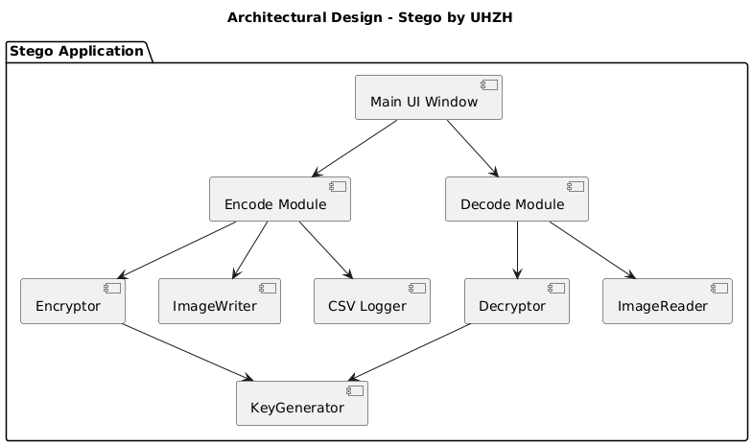

6. Code Structure
Required Packages
Bash
pip install pillow cryptography tkinterdnd2

Imports Used
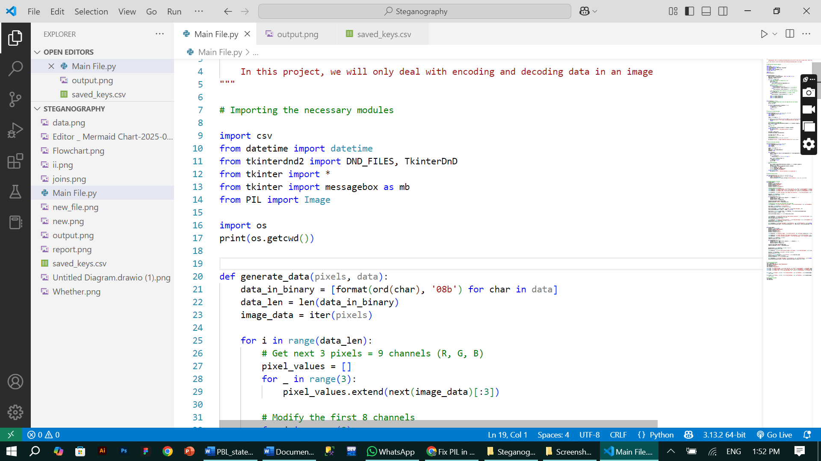
Python
import csv

Imports the CSV module to read from and write to CSV files.
Python
from datetime import datetime

Imports the datetime class to work with dates and times.
Python
from tkinterdnd2 import DND_FILES, TkinterDnD

Imports drag-and-drop support for files in a Tkinter window using tkinterdnd2.
Python
from tkinter import *

Imports all widgets (like Button, Label, etc.) from Tkinter GUI library.
Python
from tkinter import messagebox as mb

Imports messagebox module from Tkinter to show popup dialogs and renames it as mb for convenience.
Python
from PIL import Image

Imports the Image class from Pillow, a powerful image processing library.
Python
import os

Imports the os module to interact with the operating system (like file paths, directories, etc.).
Python
print(os.getcwd())

Prints the current working directory to the console (the folder where the script is being run).
Key Functions
Function | Description
generate_data(pixels, data) | Converts data to binary and hides it in pixels
encryption(image, data) | Writes encoded data into image
main_encryption(img_path, text, name, password) | Encrypts, encodes, saves image
generate_key(password) | Derives a 32-byte Fernet key from password
encrypt_message(text, password) | Encrypts plain text using derived key
main_decryption(img_path, password, widget) | Decodes, decrypts, displays message
decrypt_message(token, password) | Decrypts cipher text using password
save_password_to_csv(image, password) | Logs image name + key to saved_keys.csv

generate_data(pixels, data)
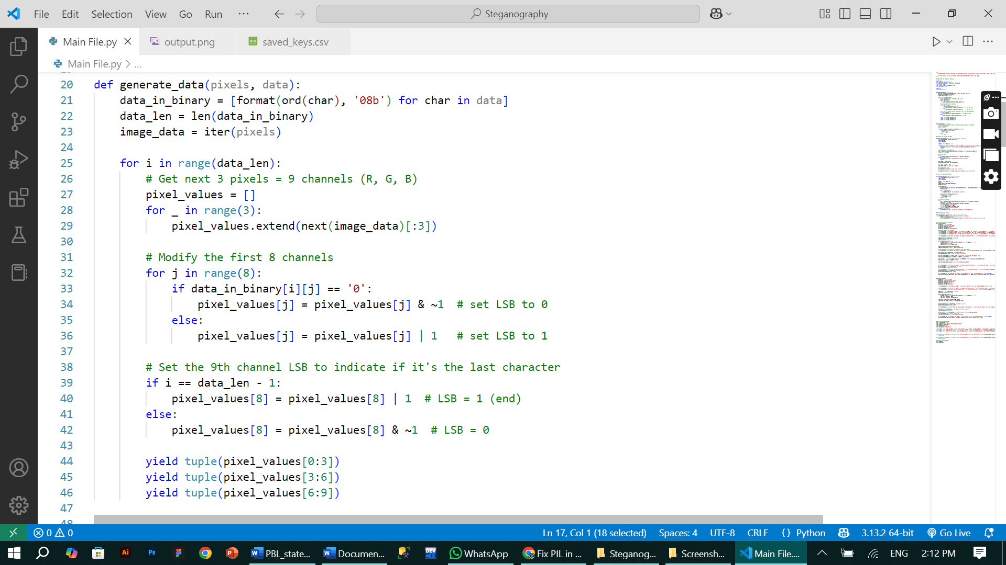
encryption(image, data)
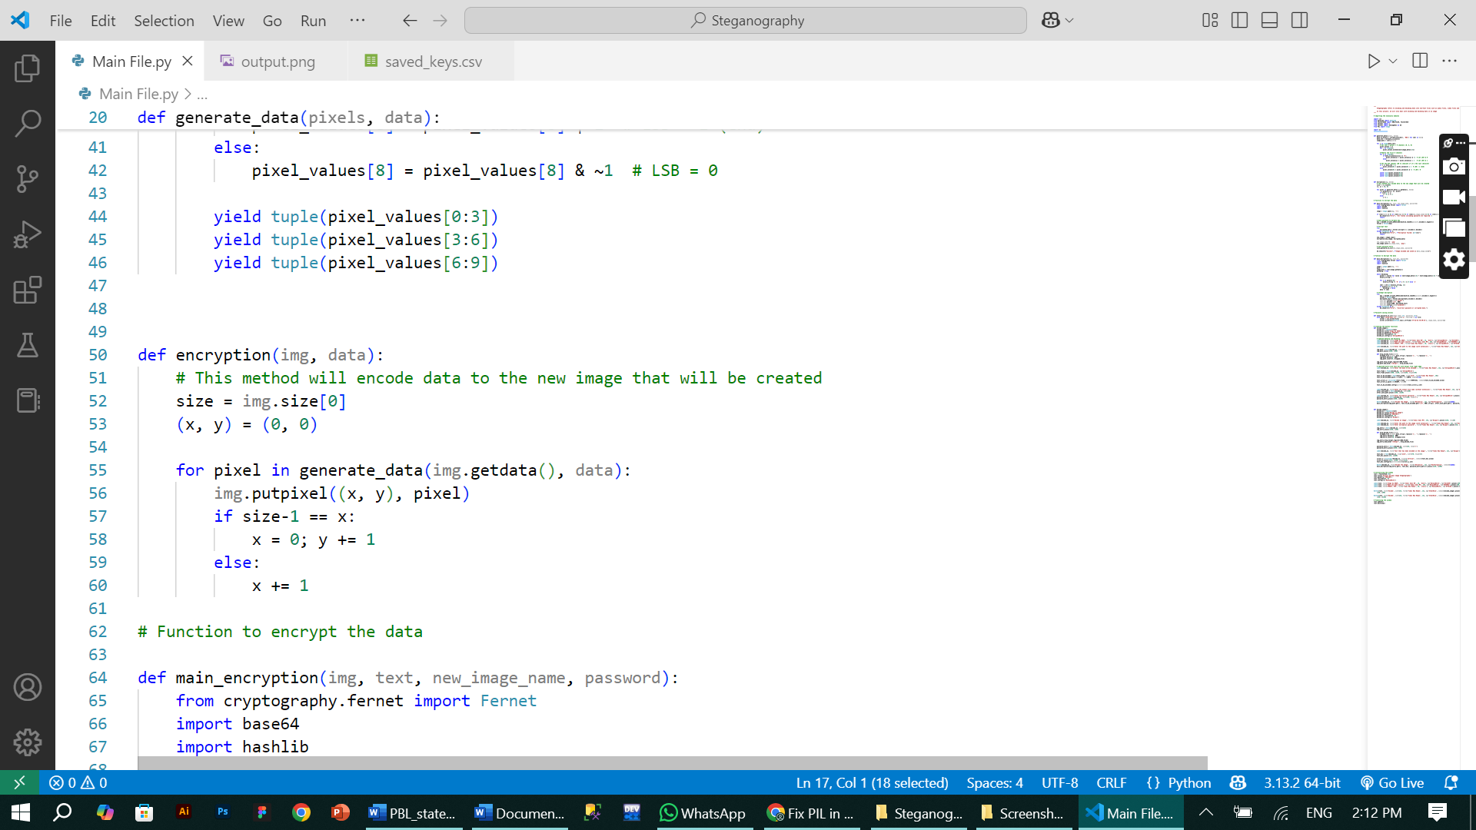
main_encryption(img_path, text, name, password)
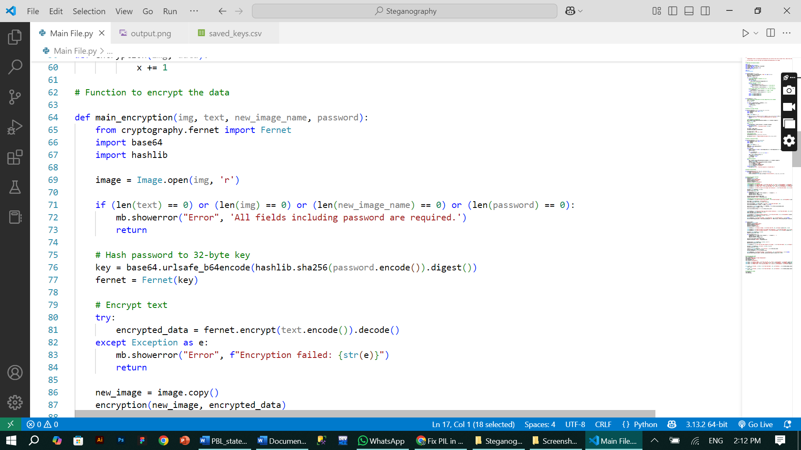
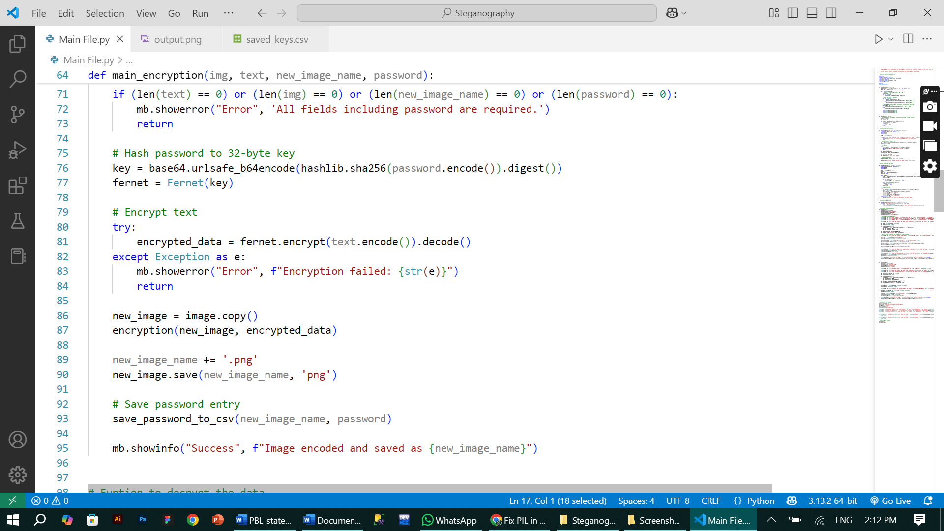
generate_key(password)


save_password_to_csv(image, password)
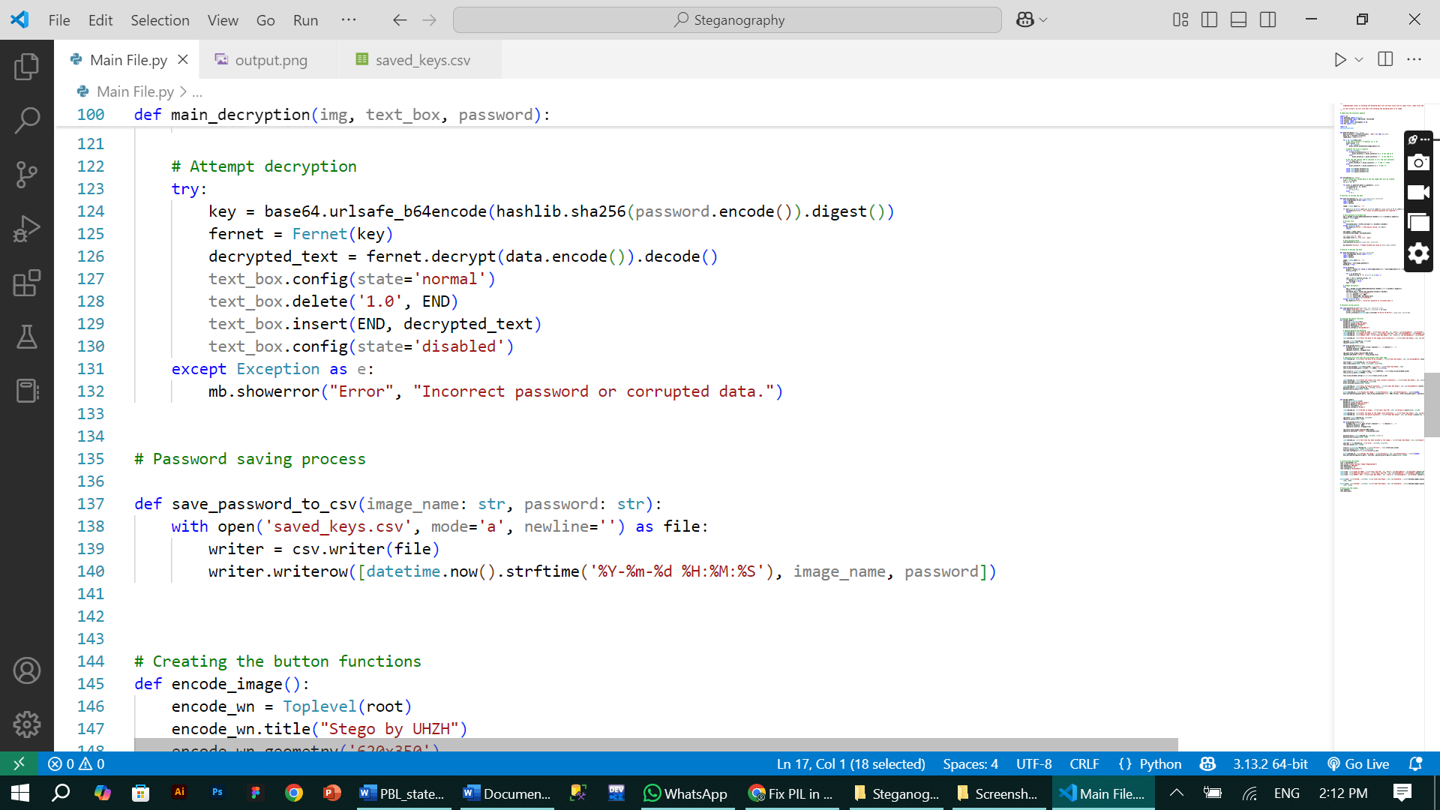

main_decryption(img_path, password, widget)
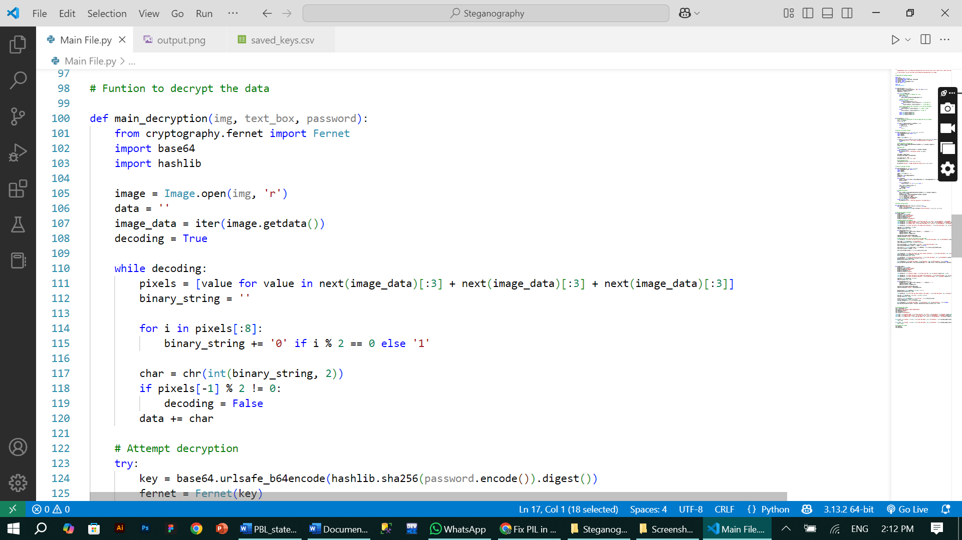
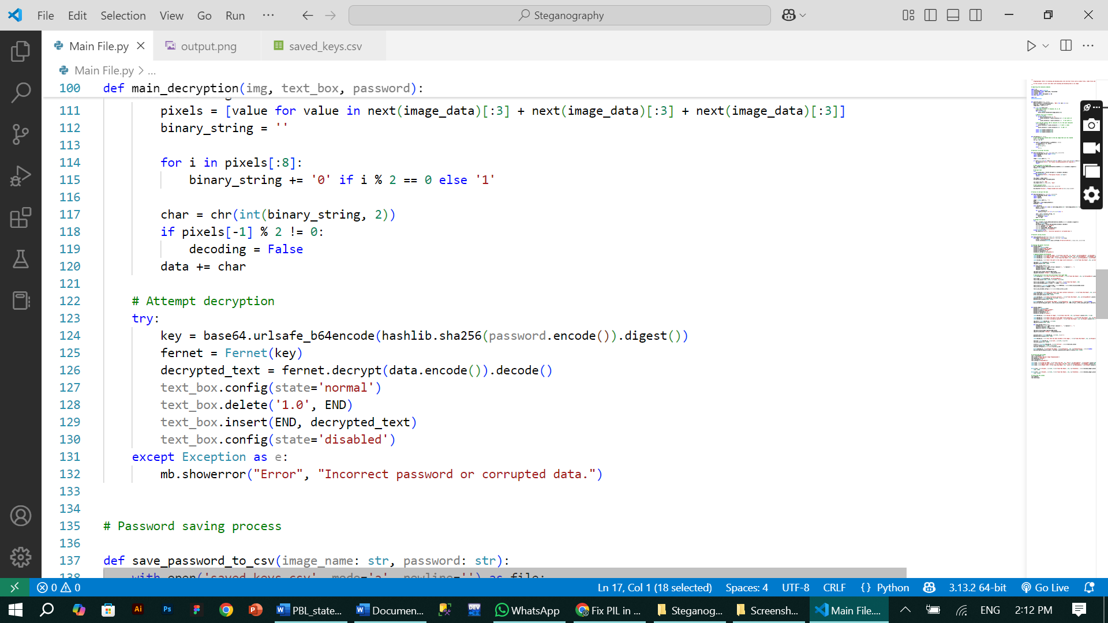
decrypt_message(token, password)
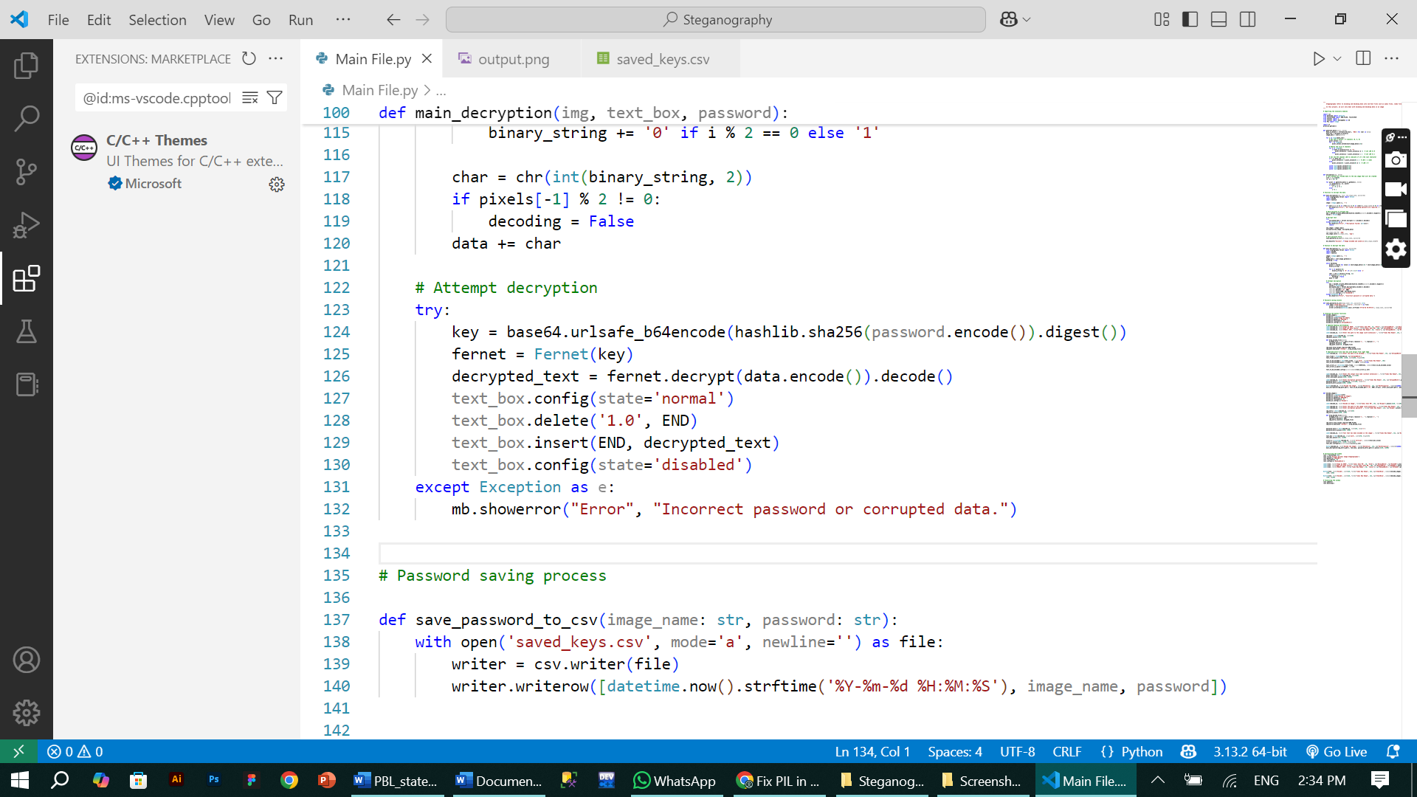

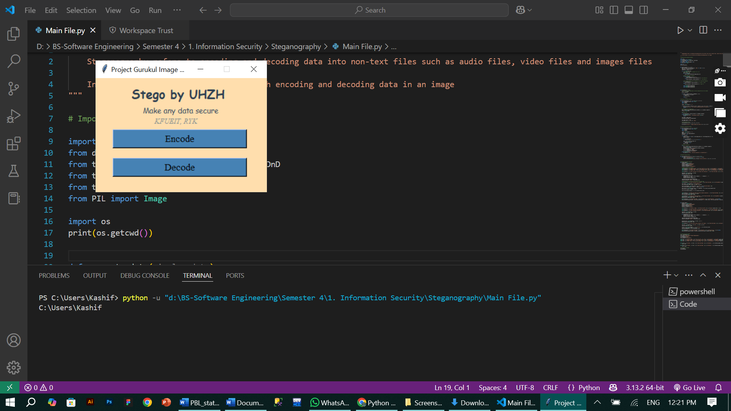
7. GUI Overview
Main Window:
- Title: “Stego by UHZH”
- Buttons: Encode | Decode
- Labels: Slogan (Make any data secure)
University (KFUEIT, RYK)
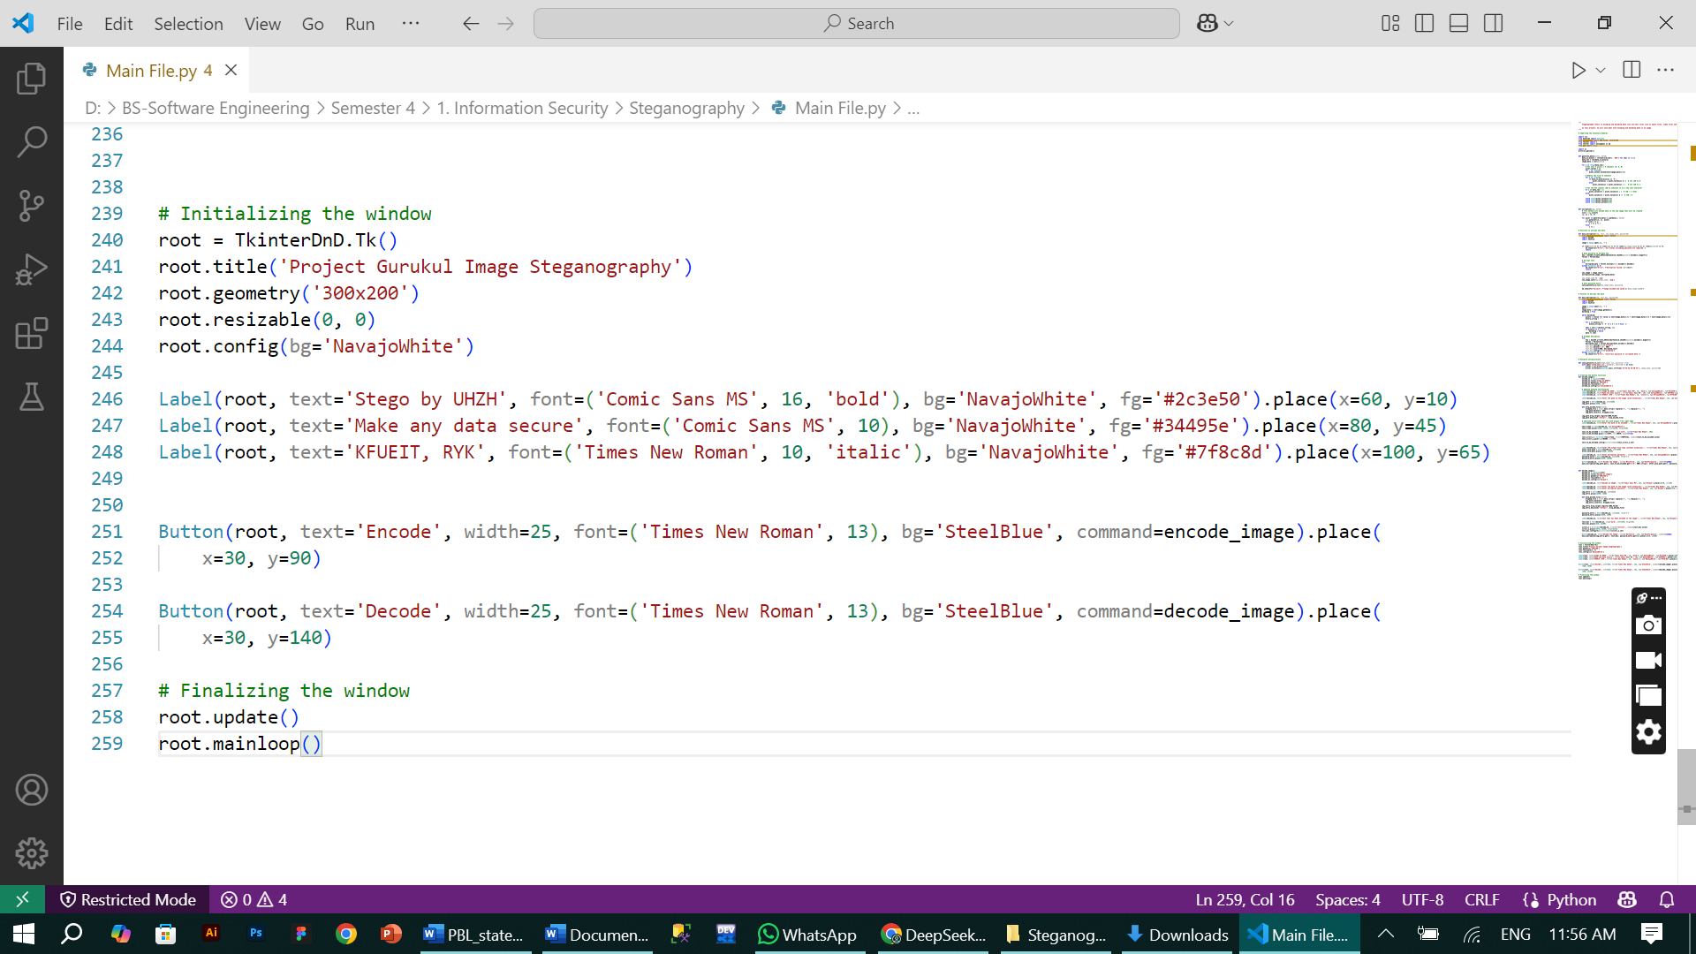
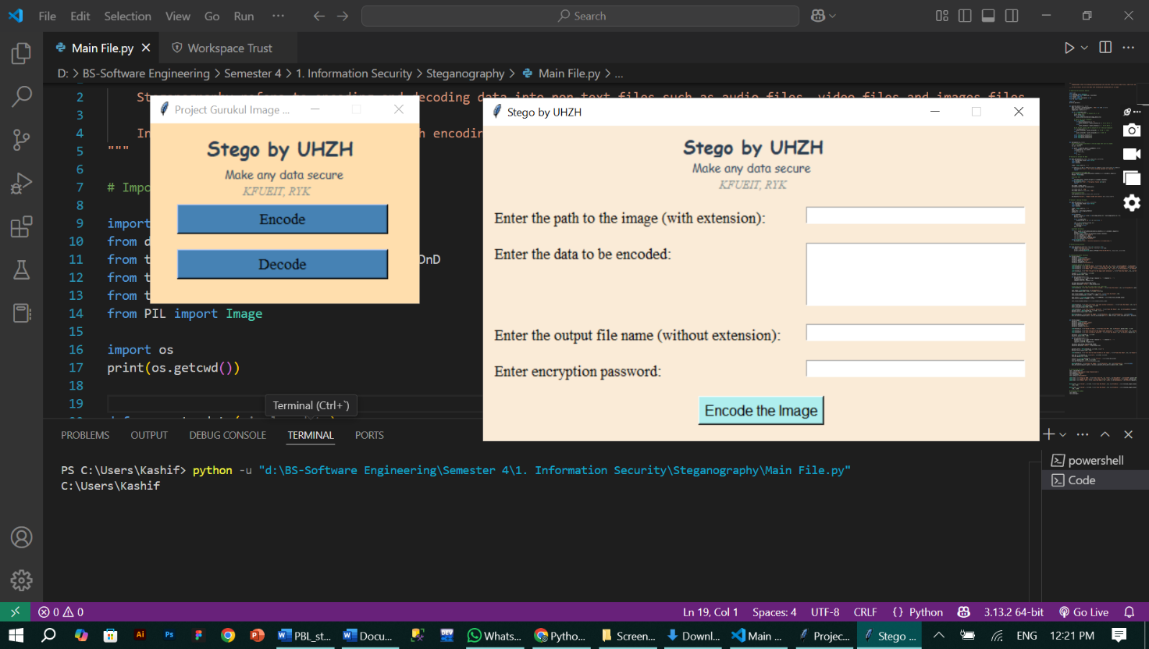
Encode Window:
- Drag/drop or browse image
- Multi-line scrollable message box
- Password entry (masked)
- Save file name
- Encode button

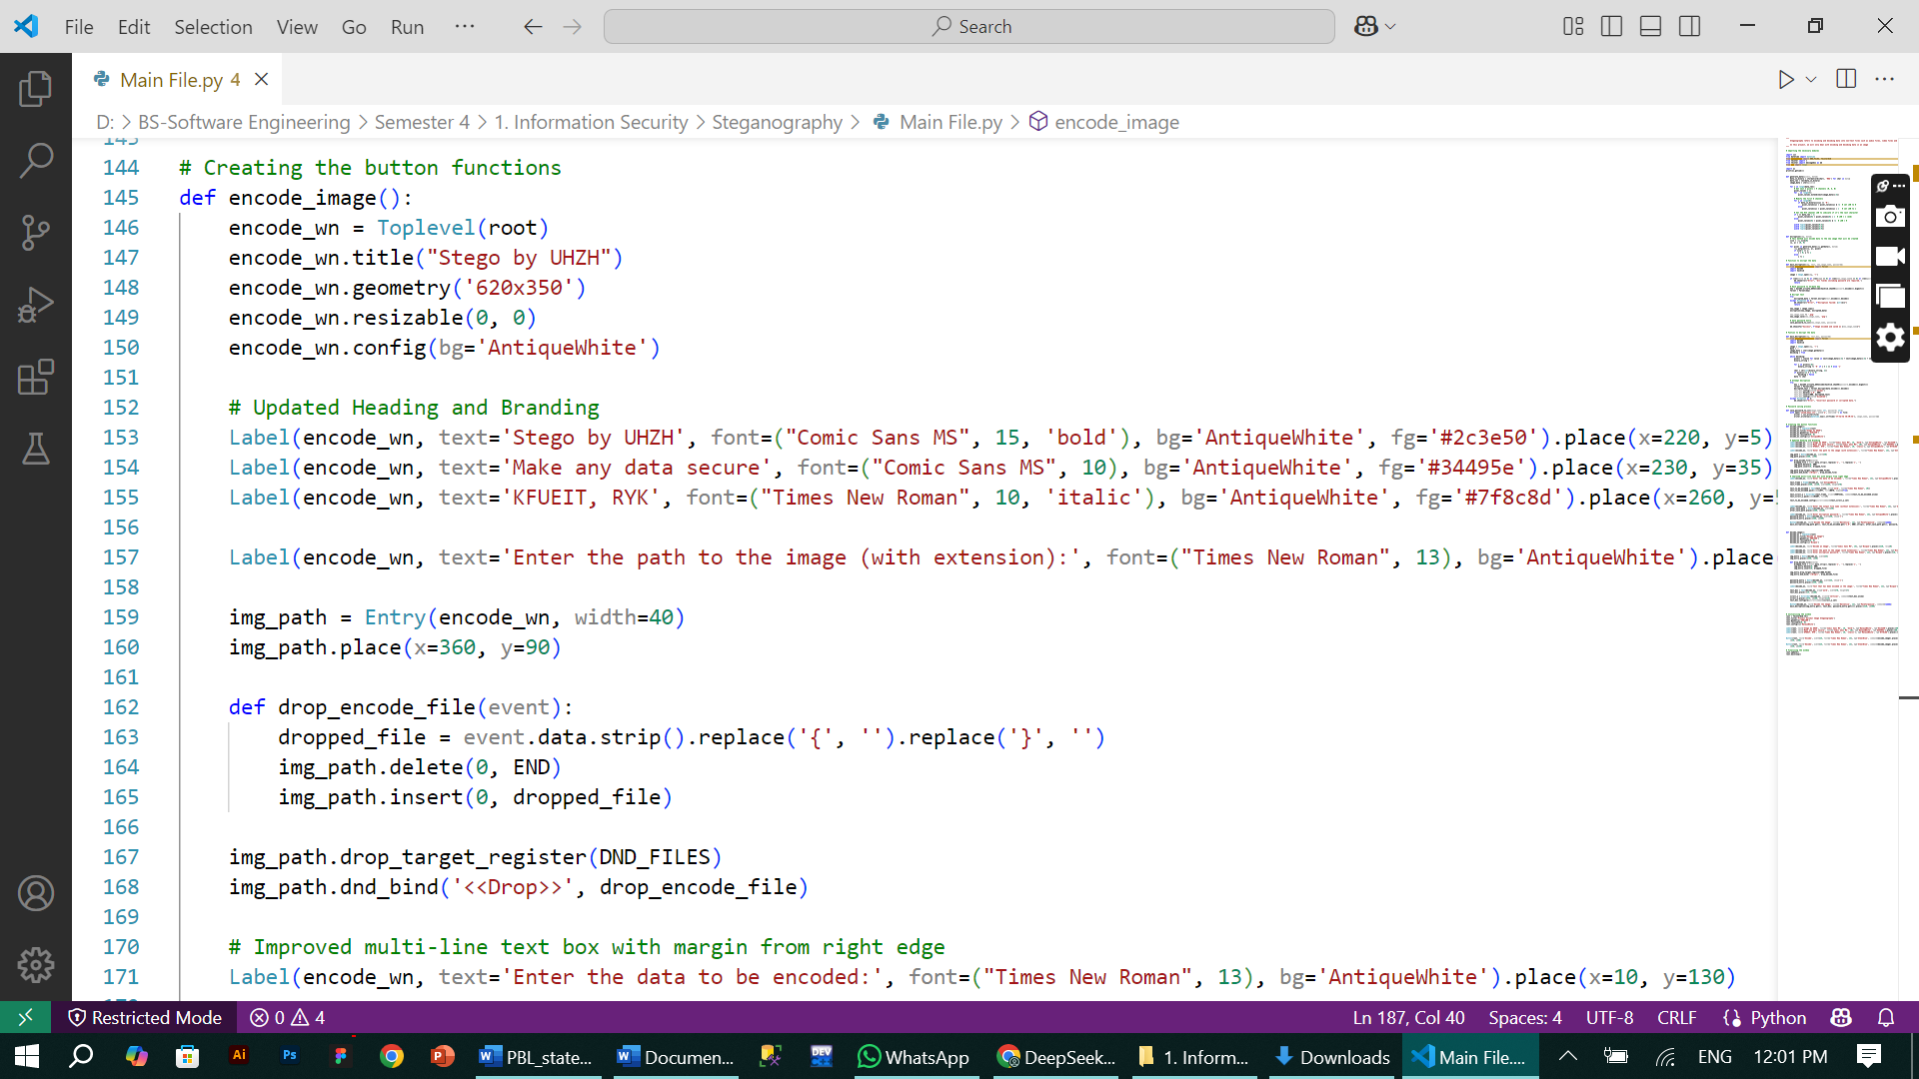

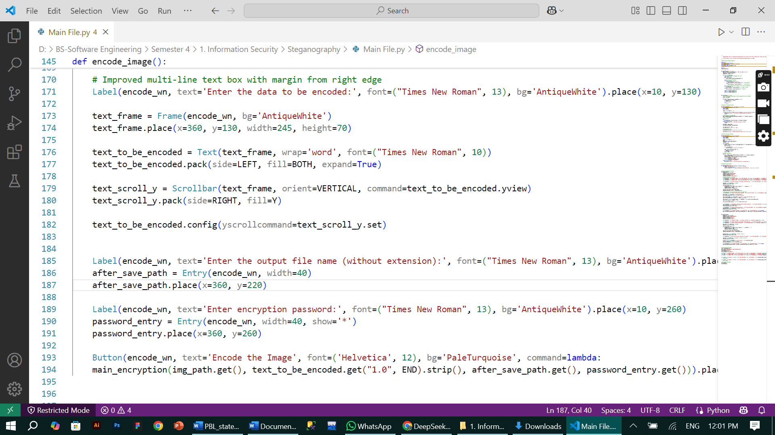

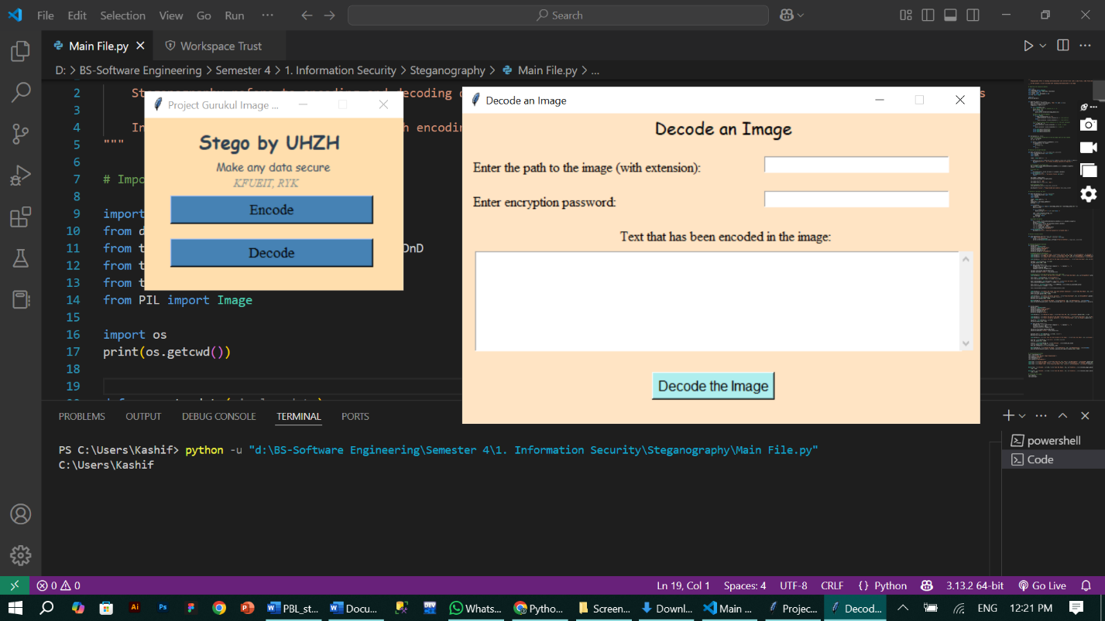
Decode Window:
- Drag/drop or browse image
- Password entry
- Scrollable decoded message box
- Decode button

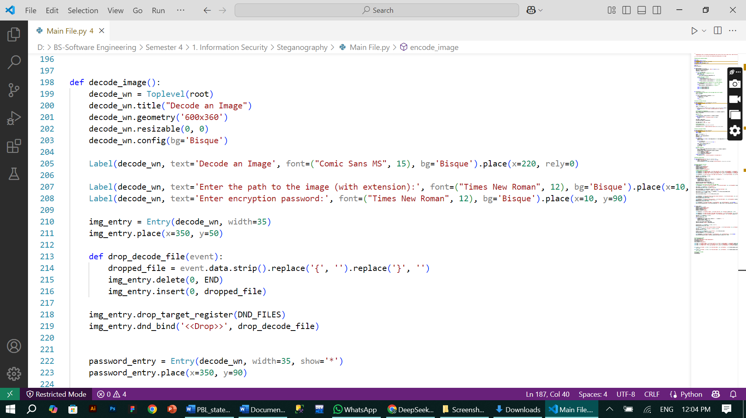
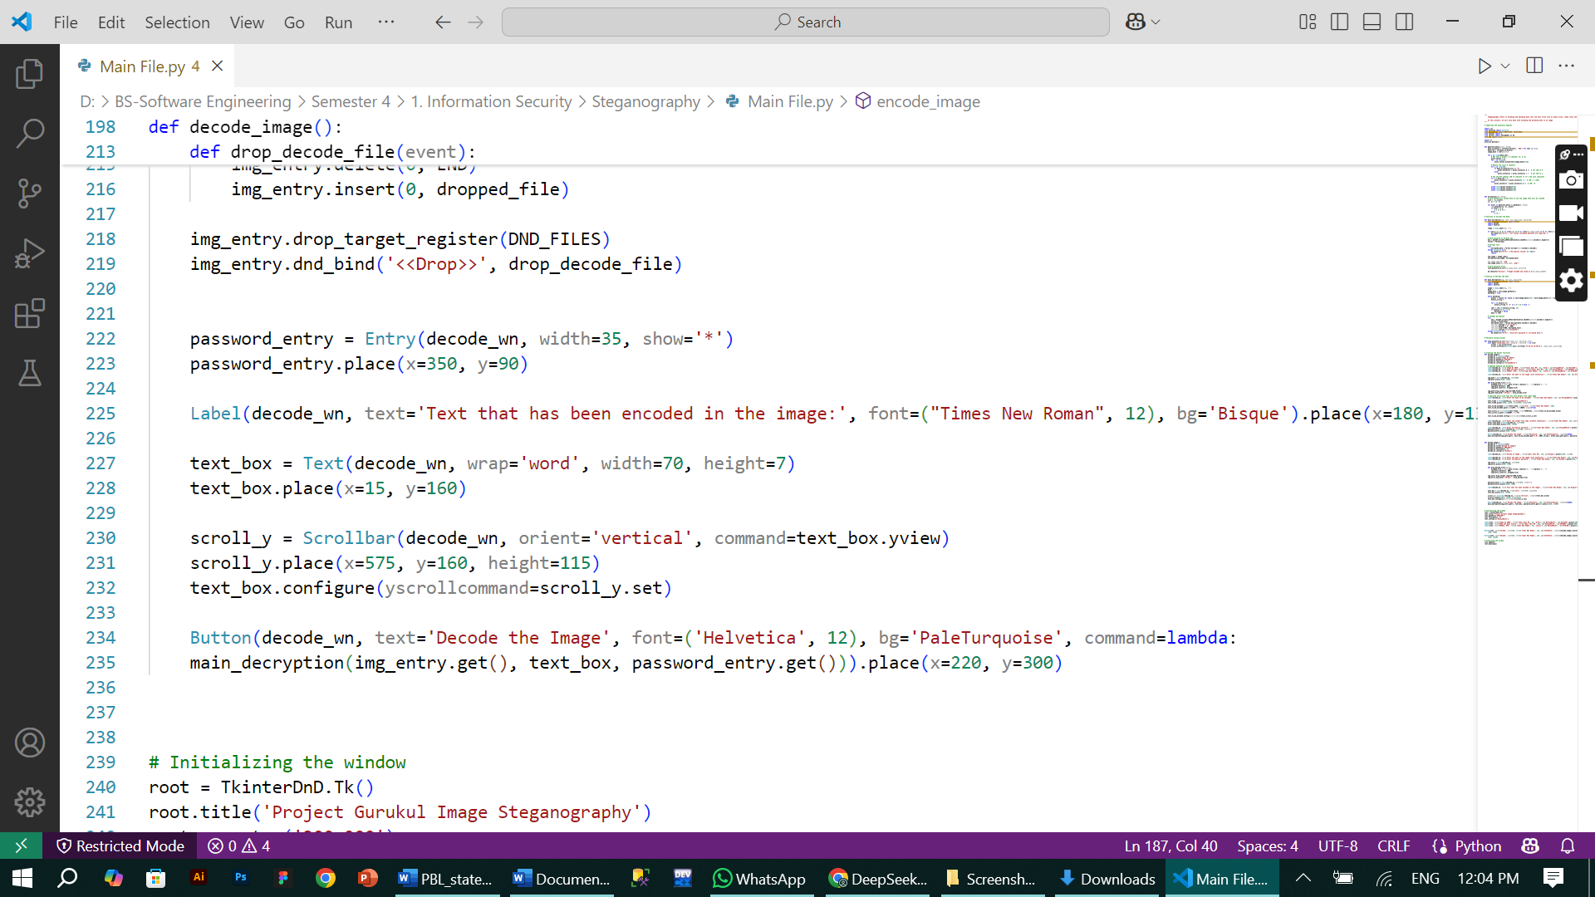

- Consistent Branding: All windows maintain the "Stego by UHZH" identity
- Drag/Drop Functionality: Uses tkinterdnd2 for modern file handling
- Security: Password fields are masked (show='*')
- User Experience: Scrollable text areas with proper view control
- Layout: Clean alignment with consistent spacing and theming
8. Functional Explanation
Image Encoding:
- User selects image (i.e., png, jpg, jpeg)
- Inputs message and password.
- Message is encrypted.
- Converted to binary.
- Binary data embedded into image pixels (LSB).
- Image is saved (by default png)
Image Decoding:
- User selects image + password.
- Extracts LSB bits.
- Rebuilds encrypted string.
- Attempts decryption using password.
- If successful, displays original message.

9. Encryption Logic
- Key Generation Process (Password is hashed using SHA-256)
The `generate_key()` function first hashes the user's password using SHA-256, creating a fixed-length 256-bit (32-byte) cryptographic hash. This hash is then URL-safe base64 encoded to ensure compatibility with Fernet's encryption requirements while avoiding special characters that might cause issues in storage or transmission.
- Fernet Encryption Foundation (Result is converted to 32-byte key with base64.urlsafe_b64encode())
The resulting 32-byte key serves as the foundation for Fernet's symmetric encryption, which uses AES-128 in CBC mode with PKCS7 padding internally. This two-step process (hashing + encoding) transforms variable-length passwords into cryptographically strong keys suitable for professional-grade encryption.
- Security Advantages (Encrypted using Fernet.encrypt() from cryptography)
SHA-256 hashing ensures password strength isn't limited by user input length while preventing rainbow table attacks. The URL-safe base64 conversion maintains cryptographic integrity while making the key filesystem and network friendly for practical applications.
Python
def generate_key(password):
return base64.urlsafe_b64encode(hashlib.sha256(password.encode()).digest())

10. Steganography Logic
- Each character = 8-bit binary.
- Iterate image pixels and modify LSBs to match data bits.
- End of message marked by special pixel.

11. Line-by-Line Code Explanation
Refer to Appendix section for full code.
Each function and import is explained previously (see “Imports” section). Highlights:
- Text(..., wrap='word') allows multiline inputs.
- Scrollbar(...) gives vertical scroll for large messages.
- drop_target_register() and dnd_bind() allow drag-and-drop.
- Image.getdata() accesses pixel array.
- pixel % 2 used to set LSBs to 0 or 1.

12. User Flow
- Launch GUI → Click “Encode”
- Select image → enter message, password, output name
- Click “Encode” → Image saved
- Click “Decode” → select image and enter password
- Message displayed if password matches

Activity Diagram (Flowchart)
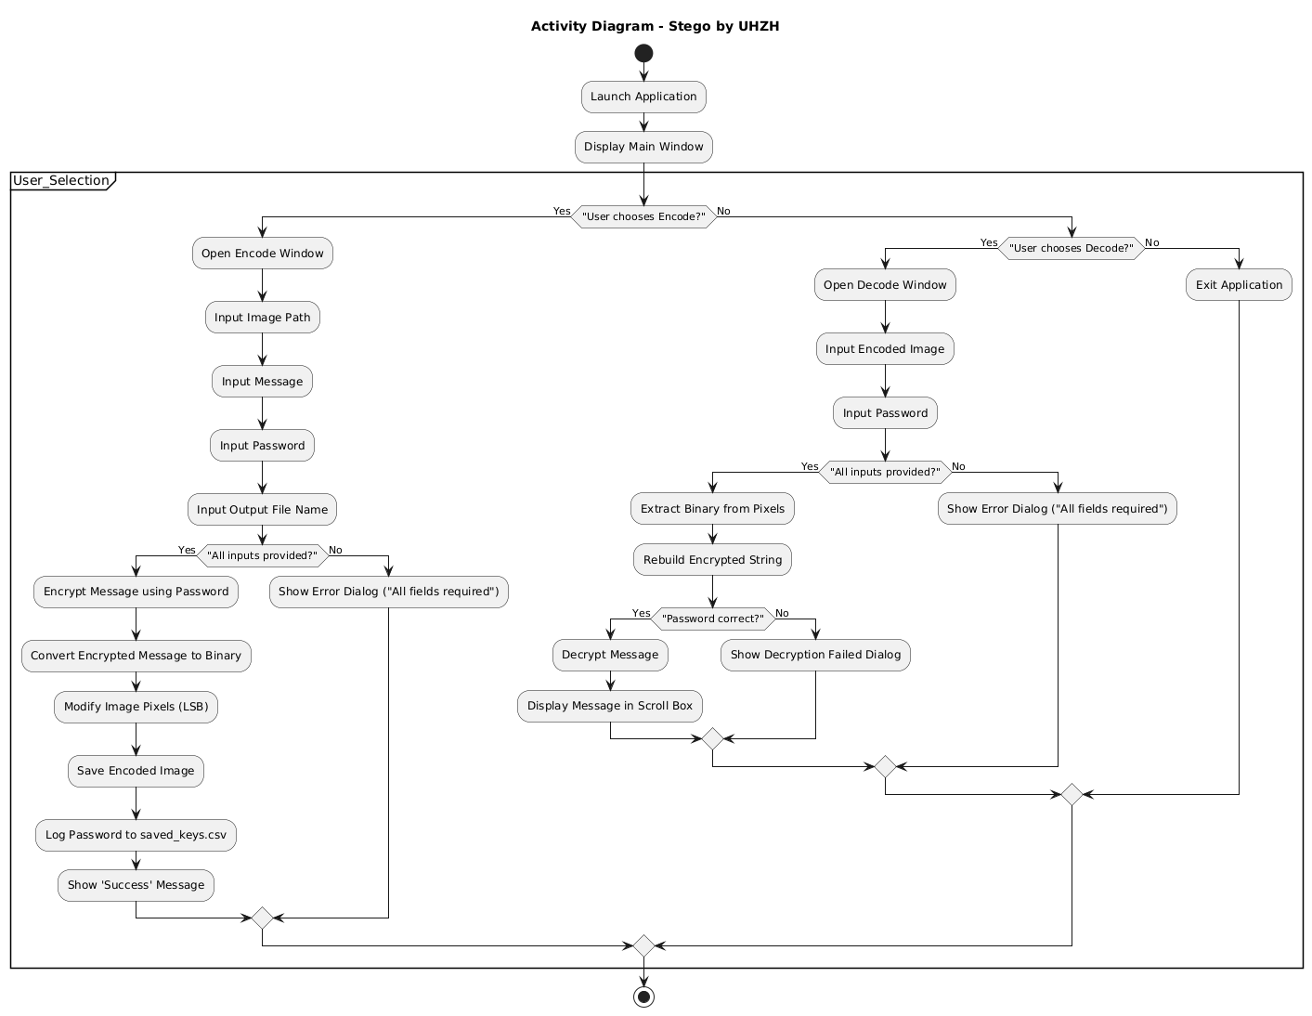
Use Case Diagram
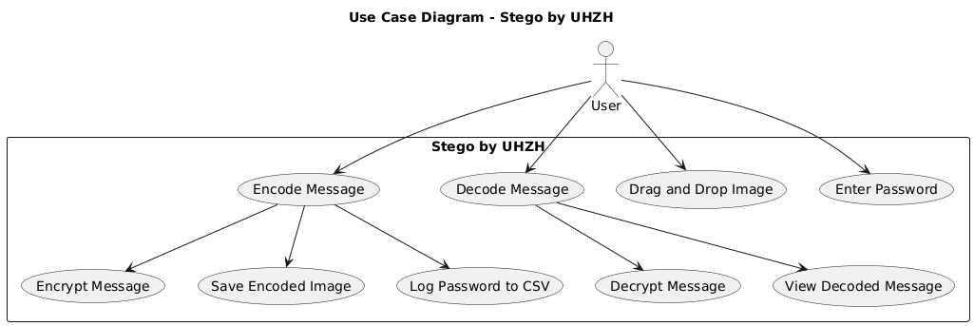
Sequence Diagram
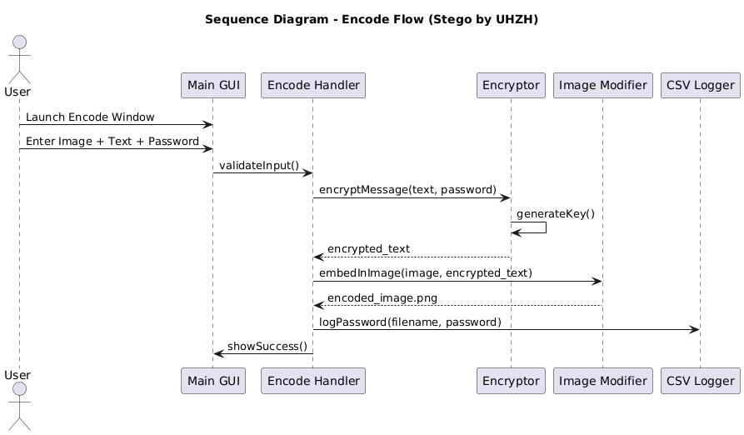
13. Test Cases & Validation
CASE | INPUT | EXPECTED RESULT
Valid password | Match | - When the correct password is entered during decoding  - System successfully decrypts and displays the hidden message
Wrong password | Mismatch | - When an incorrect password is provided  - System shows "Incorrect password" error and prevents message disclosure
Long message | >1000 chars | - When embedding large text content  - GUI scrollbars activate and all characters encode/decode properly
Dragged image | Valid file | - When user drags-drops a supported image file  - File path automatically appears in the input field
Empty fields | Any | - When required fields are left blank  - System shows "All fields required" error before processing

Each case verifies critical functionality while maintaining security and usability standards. The tests cover both normal operations and error handling scenarios.

14. Limitations & Challenges
- Plain Text Password Storage
- Passwords are currently saved in CSV files without encryption
- Creates security vulnerability if the file is accessed by unauthorized parties

- Limited Image Format Support
- Only works with PNG and JPG file formats
- Does not support other common formats like BMP, GIF or WEBP

- Image Size Requirements
- Source image must have enough pixels to store the complete message
- Larger messages require proportionally bigger image files

15. Security Considerations
- Password Storage Risks
- Production systems should never store passwords in plain text
- Current implementation is only for demonstration purposes

- Recommended Improvements
- Should use password hashing (like bcrypt) instead of storage
- Ideally implement proper encrypted credential management

- CSV File Purpose
- Used here solely for educational visibility
- Shows the encoding/decoding process clearly for learning

16. Output & Results
- Encoded images saved in same folder.
- Decoded message appears in scrollable box.
- saved_keys.csv logs entries like:
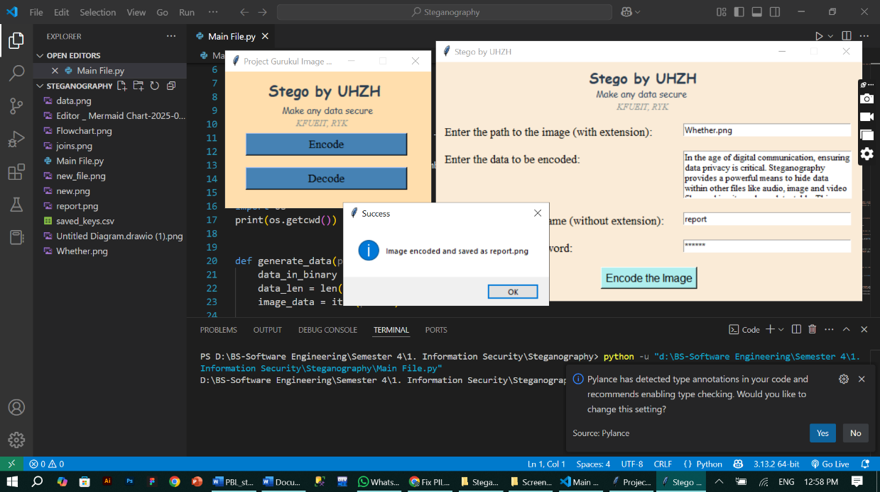

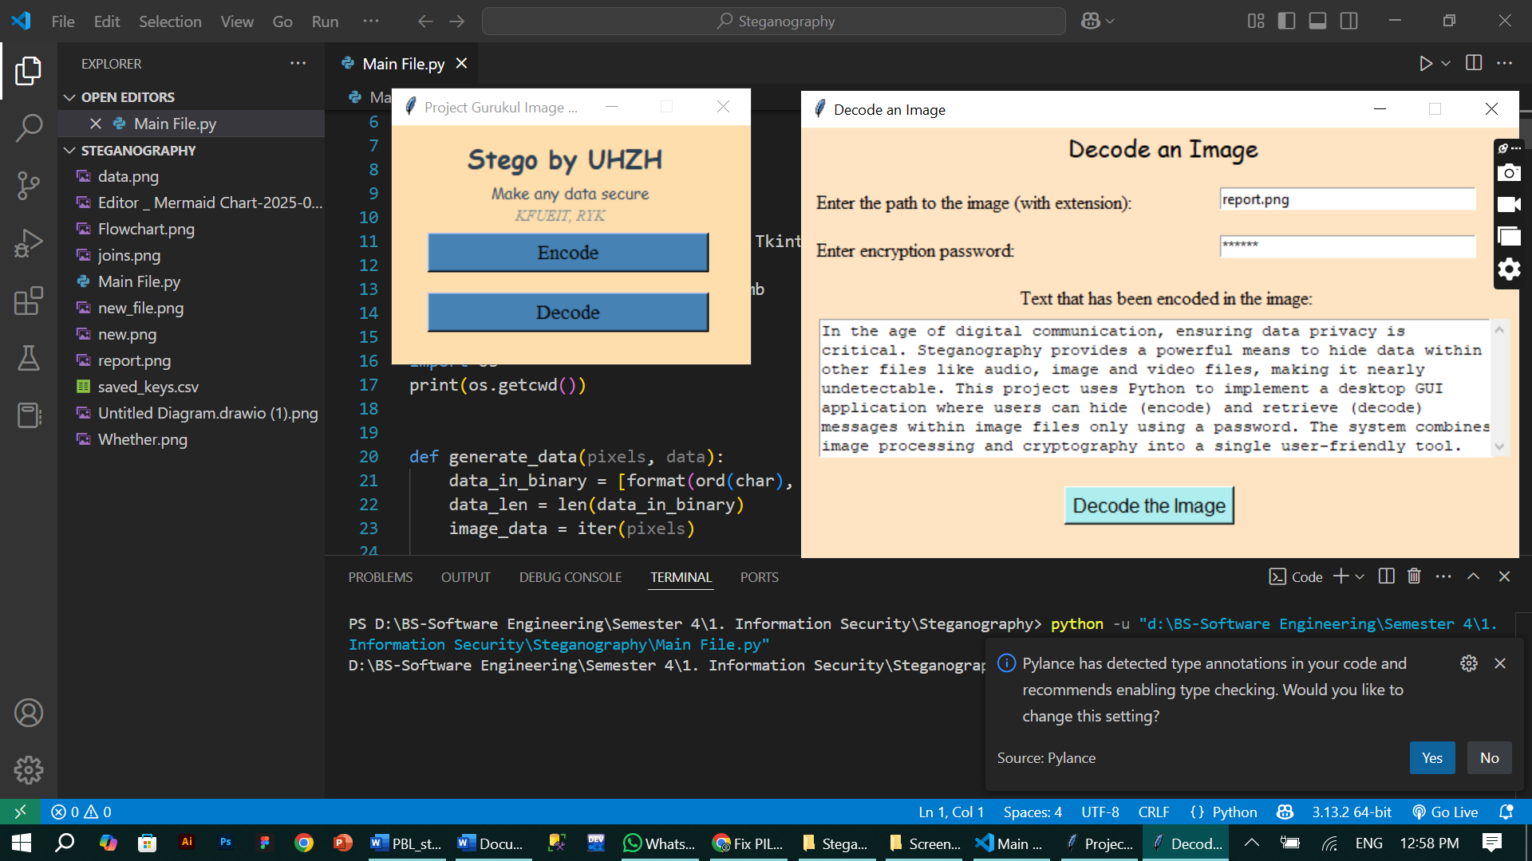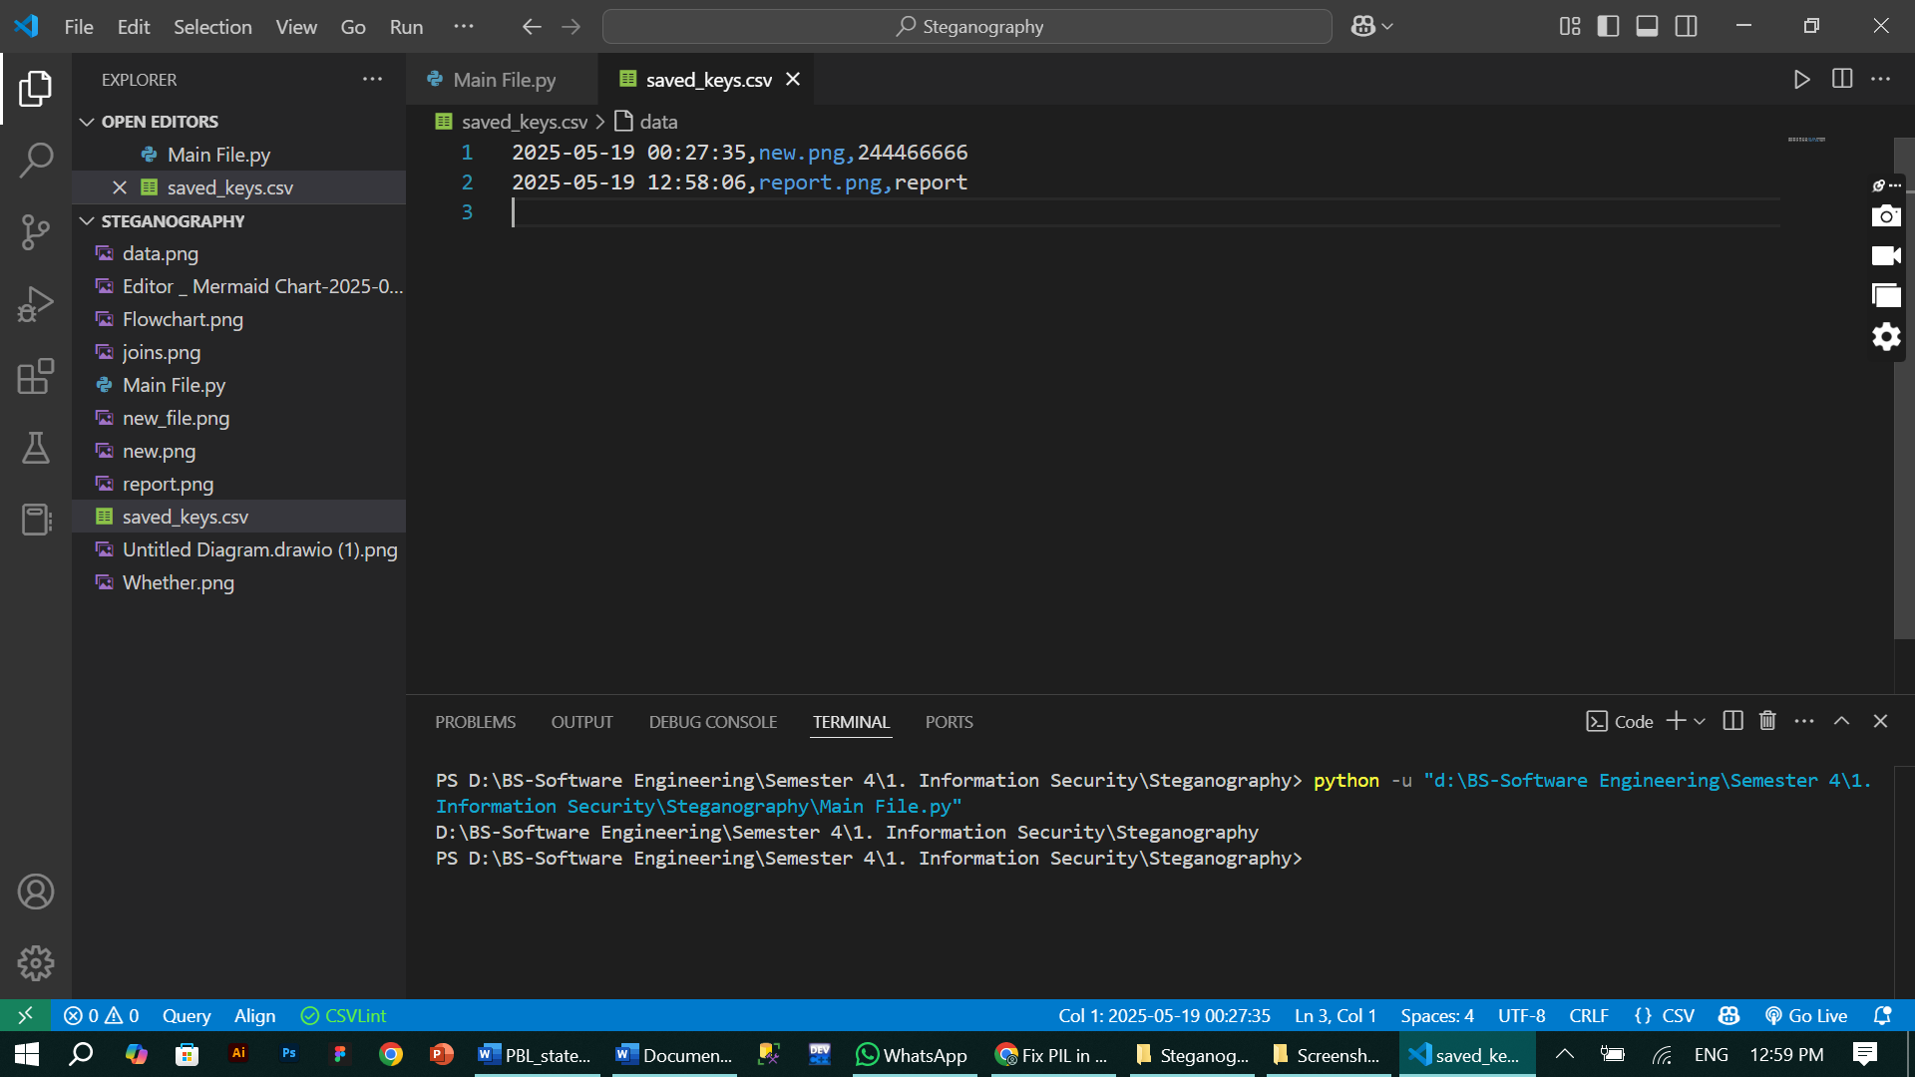

17. Future Enhancements
- Encrypt files (not just text)
{already implemented in phase-2 in which picture is encrypted behind another picture}.
- Add password strength meter
- Export decoded message to text file
- Build .exe for offline distribution
- Mask/secure CSV with encryption
18. Conclusion
This project successfully combines image steganography and secure encryption into a user-friendly Python desktop app. With complete functionality, it demonstrates real-world cryptographic practice and GUI design, while remaining extendable for future phases.

19. References
- Python Official Docs
- https://projectgurukul.org/
- Cryptography.io - Fernet
- Chatgpt

User Interface Testing
The User Interface (UI) was tested to ensure smooth interaction and usability. Key aspects included:
1. Drag-and-Drop Functionality
- Test Case: Drag a valid PNG/JPG image into the input field.
- Expected Result: The file path should auto-fill in the entry box.
- Actual Result: The path appears correctly, confirming successful detection.
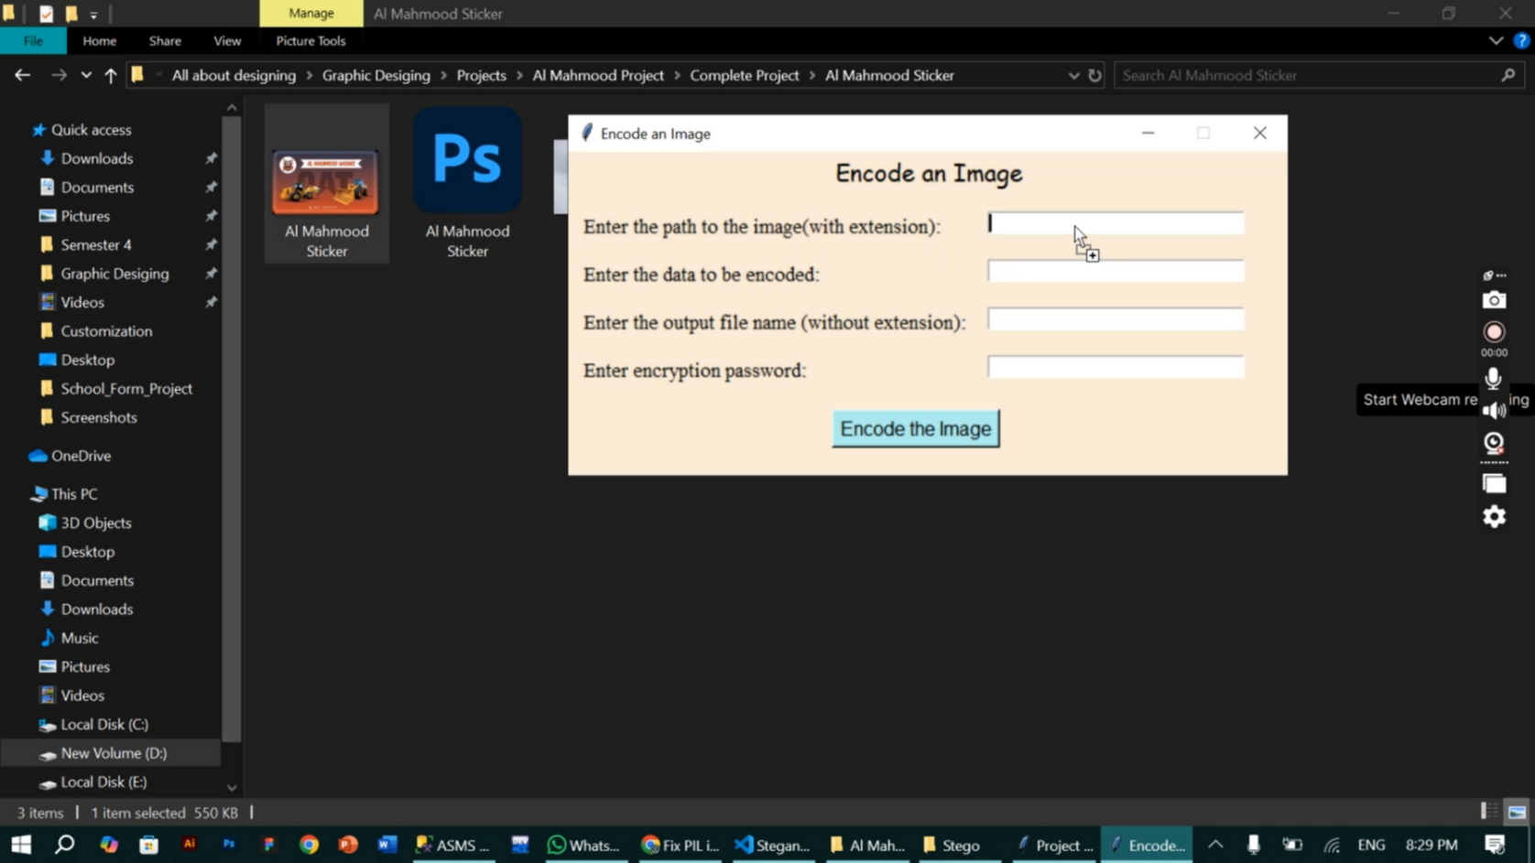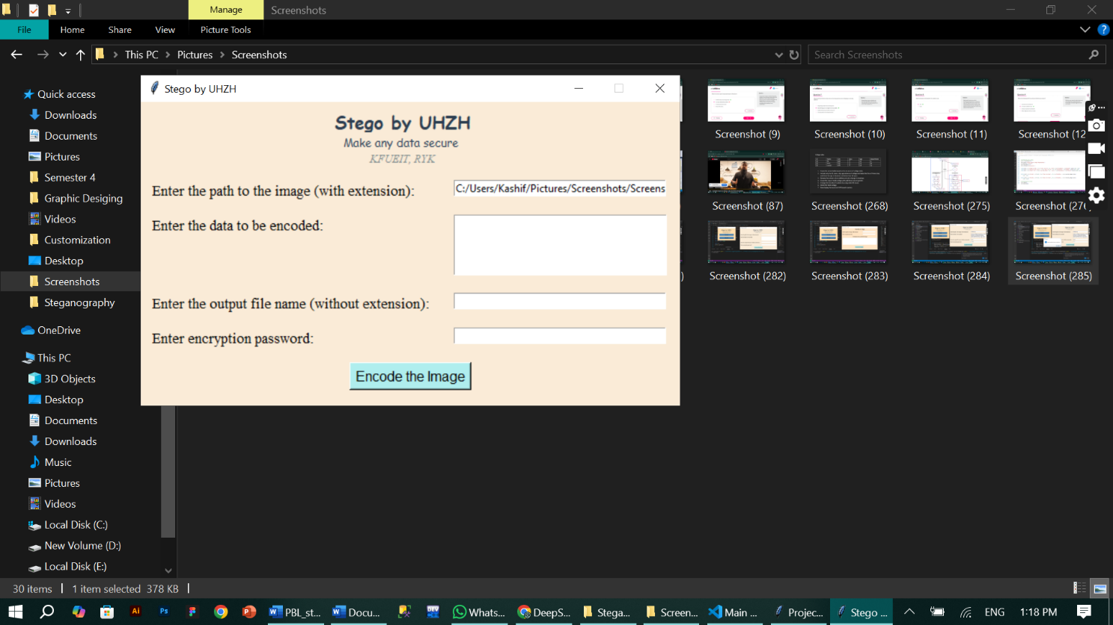
2. Input Validation
- Test Case: Leave password or image fields blank and click "Encode."
- Expected Result: An error popup ("All fields required!") should appear.
- Actual Result: The system blocks submission and shows the warning.
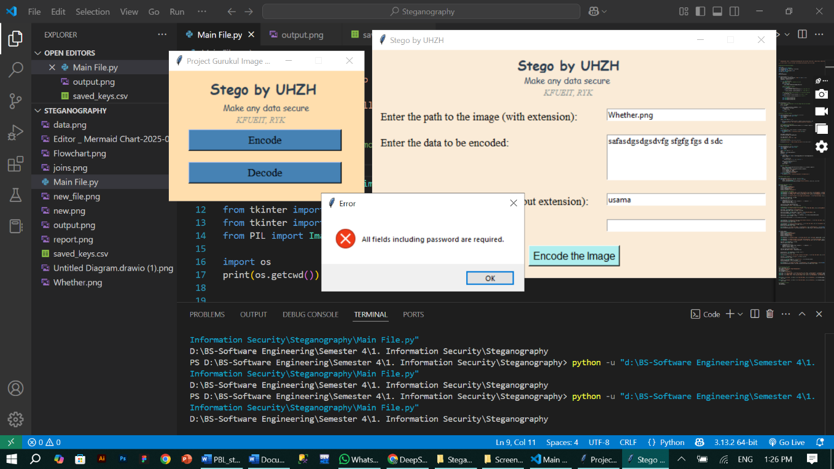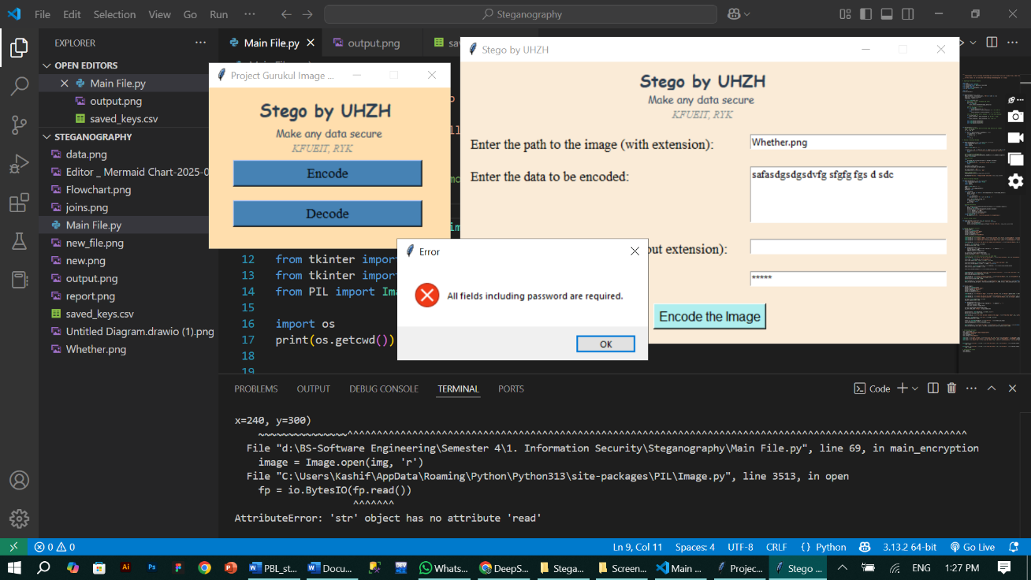
3. Scrollable Text Areas
- Test Case: Enter a message exceeding 1000 characters.
- Expected Result: Scrollbars activate, allowing full message viewing.
- Actual Result: The text box scrolls smoothly without truncation.


Validation (Functional Testing)
The core functionality was rigorously tested to ensure reliability:

1. Encoding & Decoding Accuracy
- Test Case: Encode "Hello World" with password "1234," then decode.
- Expected Result: The decoded output matches the original message.
- Actual Result: Correct output retrieved with the right password.
2. Password Mismatch Handling
- Test Case: Decode with an incorrect password.
- Expected Result: Error message ("Incorrect password or corrupted data").
- Actual Result: System rejects access and displays the error.

3. Image Size Sufficiency
- Test Case: Encode a large text file into a small image.
- Expected Result: Error if pixels are insufficient for the message.
- Actual Result: Prevents encoding if the image is too small.

Outcome:
All test cases passed, confirming the UI is intuitive and the steganography functions work as intended. Security warnings and input validations operate correctly to guide users.

